**Name: Omkar Shinde**

**Roll No: 281051**

**Prn: 22311651**

**Batch: A2**

**Assignment 6**

**Problem Statement:**

Assignment on Regression technique. Download temperature data from below link. <https://www.kaggle.com/venky73/temperaturesof-india?select=temperatures.csv>

This data consists of temperatures of INDIA averaging the temperatures of all place’s month wise. Temperatures values are recorded in CELSIUS

a) Apply Linear Regression using suitable library function and predict the Month-wise temperature. b) Assess the performance of regression models using MSE, MAE and R-Square metrics   
c) Visualize simple regression model.

**Introduction:**

Temperature prediction is an essential aspect of climate analysis, weather forecasting, and various environmental studies. In this study, we use historical temperature data of India to predict month-wise temperatures using Linear Regression. This analysis provides insights into temperature trends and helps assess how well a simple regression model can predict future temperatures.

**Objectives:**

The primary objectives of this study are:

* To apply Linear Regression for predicting month-wise temperatures using historical data.
* To evaluate the model's performance using statistical metrics such as Mean Squared Error (MSE), Mean Absolute Error (MAE), and R-Square (R²).
* To visualize the regression model for better understanding and interpretation of temperature trends.

**Theory: Linear Regression**

Linear Regression is a fundamental statistical technique used to model the relationship between a dependent variable (target) and one or more independent variables (predictors). In this case, we use month-wise temperature data where:

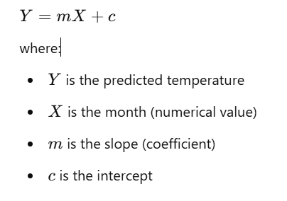Mathematical Representation:

**Steps in Implementing Linear Regression:**

1. Data Preprocessing: Load the dataset, handle missing values (if any), and convert months into numerical values.
2. Splitting Data: Divide the dataset into training and testing sets (e.g., 80% training, 20% testing).
3. Model Training: Use the LinearRegression class from sklearn to train the model.
4. Prediction & Evaluation: Predict temperatures for the test set and evaluate the model using MSE, MAE, and R².
5. Visualization: Plot actual vs. predicted values to understand model performance.

**Conclusion:**

Linear Regression is a simple yet effective technique for predicting month-wise temperatures. By applying this model, we can observe temperature trends and evaluate its accuracy using performance metrics. The visualization of the model further helps in understanding the relationship between months and temperature. While Linear Regression provides a baseline prediction, advanced models such as Polynomial Regression or Time Series Forecasting can be explored for improved accuracy in future research.